Educator’s Guide for Pedro’s Pan: A Gold Rush Story

Fry Readability: 1
Lexile Measure: AD540L
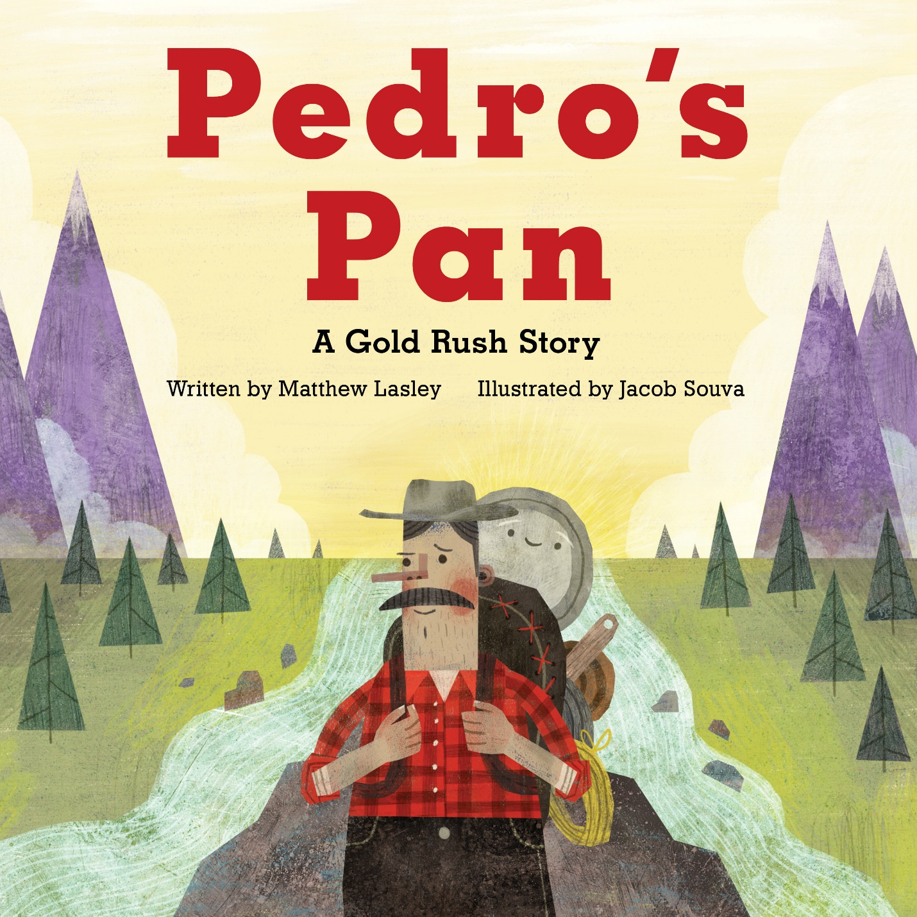

Book Summary:
Pedro and his best friend Pan are in search of gold. But as they search over mountains and across streams, they don’t seem to have any luck in finding the gold nuggets. Pan begins to worry if he’s broken. But with patience and hard work, one day the two finally discover something shining in a creek bed, just waiting for them to find.
There have been several Gold Rushes throughout history, bringing people out to the West in the hopes of discovering riches. Pedro’s Pan is the inspired story of just one person affected—Felice Pedroni, also known as Felix Pedro, an Italian immigrant prospector who discovered gold in Interior Alaska and launched the 1902 Fairbanks Gold Rush.

About the Author:
Matthew Lasley is the son of a gold miner in Alaska and the Klondike, and has spent many hours hunched over a gold pan, even in some of the same creeks that Felix Pedro once prospected. He is now a writer and elementary school teacher, and lives in Anchorage.
For more information about Pedro’s Pan and to learn more about school visits and online presentations, visit www.matthewlasley.com.

About the Illustrator:
Jacob Souva is a New York-based illustrator and designer with a BFA in Illustration. He loves making art for children and has always wanted to visit Alaska. Visit him at www.twofishillustration.com.

Find study guides for all our books at http://www.graphicartsbooks.com/studyguides/
CLASSROOM DISCUSSION
Before Reading: For background and context, begin by discussing Gold Rushes and what they have meant in US history.
- In which states has gold been found? Do you live near the location of a Gold Rush?
- Why were people looking for gold?
- What happened when one person would find gold in the area?
Preloaded Vocabulary:
- Prospector: a person who searches for gold and other valuable minerals.
- Gold Pan: a round, dish-like pan used to help separate gold from dirt.
- Gold Rush: a time when many people try to find gold in an area at the same time.

After Reading: Encourage thinking and comprehension of the story.
- What is a gold pan?
- How do you use a gold pan to find gold? (Hint: Look on the second-to-last page of the book to learn how to pan for gold!)
- How does a gold pan catch the gold? (Hint: Look at the gold facts in the back of the book to learn about how much heavier gold is)
- What is iron pyrite, and what is it more commonly known as? How is it different from real gold?
- Where are some places prospectors like Pedro go to pan for gold? What are some hints to look for when looking for gold?
More Vocabulary:
- Black sand: Dark sands that are made from heavier minerals like iron and garnet. Indicates areas where heavy material like gold settles.
- Quartz: A common white or clear rock that is often found with gold. Quartz can come in many colors, but white is the most common.
- Rusty Quartz: Quartz rocks with red colored stains showing that other heavy metals like iron are found in the same place.
- Iron Pyrite: Also known as fool’s gold, it is a gold colored mineral that is lighter than gold but is often mistaken for gold.
- Nugget: A chunky piece of gold.

Critical Thinking: Identify other themes and discussion points in the book.
- Pedro and Pan together made a team to look for gold. Can you remember a time when you were part of a team? How did you and the other person (or people) work together to reach a goal?
- When Pedro and Pan found Fool’s Gold, how did that make them feel? Why did Pan call himself a “Fool’s Gold Pan”?
- At one point in the story, Pan thinks he’s broken. Does Pedro feel the same way? Did the two stop panning for gold? Why or why not?
- Have you ever felt like you were not good at something? How did that make you feel? What did Pedro and Pan do to be successful even after failing to find gold so many times?

ACTIVITIES
Check your local museums to see if they have an exhibit on the gold rush or even have hands-on activities for gold panning.

ART: Make your own gold! Find some small rocks and use gold paint to make the rocks resemble gold nuggets. Alternatively, you can put glue on the rocks and roll them in gold glitter. Place the rocks on parchment paper or foil to dry.

Draw a gold map. Make a list of things a prospector might need or look for when searching for gold. Draw a map guiding your prospector to the gold. Don’t forget to draw dangers that your prospector will need to avoid and go around!

SCIENCE: Simulate what gold panning is like with a few rocks of different sizes and some sand. Create your own gold nuggets (see ART above) and hide them in a sandbox or a bucket of sand. With a flour sifter or even kitchen colander and plastic toy shovels, pour sand through the sifter or colander to find the hidden gold.
You can create the same experience but with water by just placing the gold nuggets and the sand in a bucket of water. It is important to discuss gravity and how “heavier” things tend to settle to the bottom.
If you have access to a gold pan, you can practice. You can “dry” pan which works pretty much the same way as traditional panning. Desert prospectors use this technique to find gold without water.
You can buy aluminum pie pans and use them as improvised gold pans. It is important to not overload them as they will fold if too heavy.
An easy way to create the gold panning experience is to buy some bbs (I like to paint them gold) and mix them with sand. Lead and brass are heavy (though not as heavy as gold) and will imitate gold.

SOCIAL STUDIES/TECHNOLOGY:
Go online and do some research about the different gold rushes the United States went through. (For example: California Gold Rush, Fairbanks Gold Rush, Colorado Gold Rush, Georgia Gold Rush.) Then find answers to the following questions:
- When and where did this gold rush take place? Where was the actual location gold was found?
- Who were the people involved? Where were these people from?
- How did the change in population affect the area?
- What were some jobs that the gold rush created?
- Was there unpaid labor for some people? Who wasn’t being treated well? Discuss some reasons why these people were taken advantage of during the gold rush.
- Gold rushes create a large effect the area’s economy. In your research, what happened to prices of items sold where gold was found? Why?
- Can you find the value of gold at this time?
- Was it easy to find gold? Was everyone who mined for gold successful?
- What kind of tools did miners use to find gold?
- What happened to the environment where the gold was found? What are some other effects of the gold rush in terms of transportation, trade, and commerce?
- What did people use the gold for during the gold rushes? What do we use gold for today?

LEARN MORE:
Find additional resources on Pedro’s Pan at the author’s website: https://www.matthewlasley.com/
Learn more about Felix Pedro: https://alaskamininghalloffame.org/inductees/pedro.php
Read another book that takes place during a Gold Rush: Yao Bai and the Egg Pirates, by Tim J. Myers and Jacob Souva: https://www.amazon.com/Yao-Bai-Egg-Pirates-Myers/dp/1513261444/
Visit https://www.brainpop.com/search/?keyword=Gold+Rush for an educational video on the California Gold Rush and methods they used.

Word Search for Pedro’s Pan:
H T D R S K N A B R I A F J B  N M O J T N C R E E K B E D K  L O B R V K X A U F F E G R D  Q V K G D N F H N T F H H P H  A T O C I E F A B H W O R H T  K R G Y O A P J K T Q O N D Y  S Y W E V D B X Y K S V Z H L  A B M T L U J T I P J U J S V  L M A O J H L C E L N O H U L  A Z G Z J N G C P T E C J R Y  E S T T E I T C O E S F G D C  X X E R F O O L S G O L D L N  M U O A R B M Y L G Q K W O K  V A Q U C F Q A U U I Q A G O  G N Y Q D B F N X N J V Z Y F | FELIX PEDRO  GOLD RUSH  GOLD PAN  ALASKA  FAIRBANKS  QUARTZ  FOOLS GOLD  PROSPECTOR  CREEK BED  NUGGET

